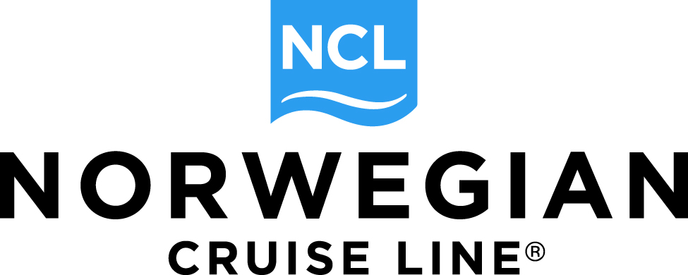

Direct Guest Reservation
Transfer Request Form

I ____________________ would like to transfer my reservation number _______________________ on the
(Guest Name) (Reservation Number)

___________________________________sailing on ______________________________ to my travel agent.
(Name of Ship) (Sailing Date)

Here is the information of my travel agency:

Travel Agency Name:_____________________________________________________

Travel Agent Name: _____________________________________________________

Travel Agency Phone Number: ____________________________________________________

The guests traveling in the stateroom are:

_____________________________________ ______________________________________

_____________________________________ ______________________________________

Reason that you would like to transfer to a travel agency (optional):

IMPORTANT: Bookings may be transferred to a Travel Agent up until 30 days from creation, if the request is made outside of Final Payment period. For new reservations booked within final payment period, that are paid in full, transfer requests can be processed if the request is received within 7 or less days of final payment application. If the transfer request involves a change in currency we cannot accommodate a transfer. If your reservation meets the required criteria and you would like to transfer your reservation please complete this form. Transfer request must be sent by one of the guests on the reservation to Norwegian. When emailing the form to us at Dispatch@ncl.com, please copy your travel partner for their reference.

_____________________________________ _______________________________________
Print Name Email address / Phone No.

_____________________________________ ______________________________________
Signature Date

Please email completed form to: dispatch@ncl.com
11/30/17

